

**United International University (UIU)**

**Dept. of Computer Science & Engineering (CSE)**

Course Code: CSE 2218 Section: F

Course Title: Data Structure and Algorithms Lab

Kruskal’s Algorithm

**Pseudocode and some sample I/O for Kruskal’s Algorithm are given below:**

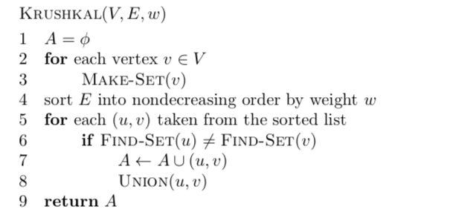

|  |  |
| --- | --- |
| **Sample Input** | **Sample Output** |
| Vertex = 5  Edge = 8  0 1 9  0 2 5  0 3 2  1 3 6  1 4 5  2 3 4  2 4 5  3 4 4 | Minimum Spanning Tree:  0 3  1 4  2 3  3 4 |
| Vertex = 4  Edge = 5  0 1 10  0 2 6  0 3 5  1 3 15  2 3 4 | Minimum Spanning Tree:  2 3  0 3  0 1 |

Prim’s Algorithm

**Pseudo-code and some sample I/O for Prim’s Algorithm are given below:**

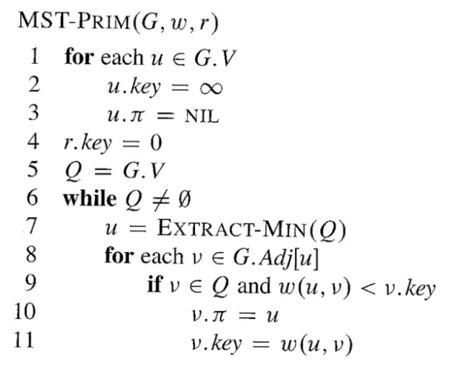

|  |  |  |  |  |
| --- | --- | --- | --- | --- |
| **Sample Input** | **Sample Output** |  | **Sample Input** | **Sample Output** |
| Vertex = 4  Edge = 5  0 1 10  0 2 6  0 3 5  1 3 15  2 3 4 | Minimum Spanning Tree:  2 3  0 3  0 1 |  | Vertex = 9  Edge = 14  1 2 4  1 8 8  2 8 11  2 3 8  3 9 2  3 4 7  3 6 4  4 5 9  4 6 14  5 6 10  6 7 2  7 9 6  7 8 1  8 9 7 | Minimum Spanning Tree:  1 2  2 3  3 9  3 6  6 7  7 8  3 4  4 5 |